Logan Hammond

23 February 2020

SDEV 300, Fair

Lab 6 Results Document

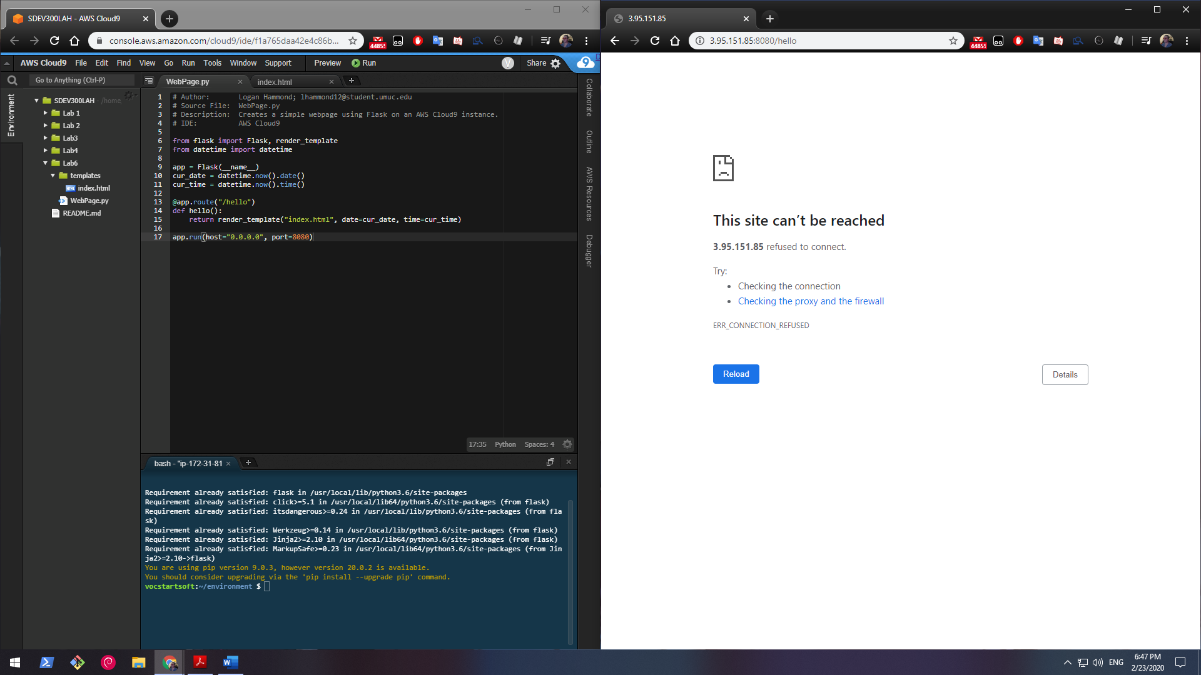

Before the program is started the webpage cannot be reached.

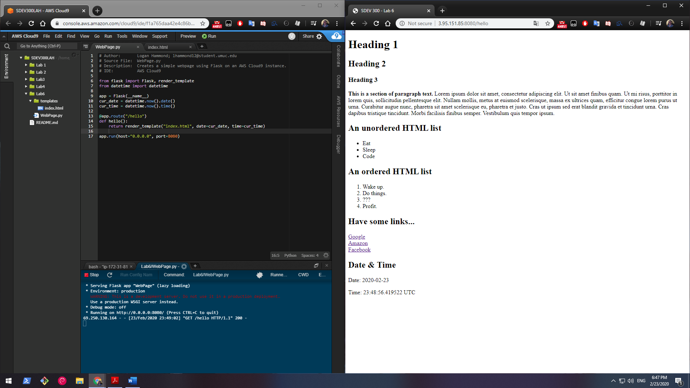

After the program is started the webpage can be reached.

Instance IPv4 address was [3.95.151.85/](http://3.95.151.85/) using port 8080 as instructed in course materials.

Accessed the website through <http://3.95.151.85:8080/hello>.

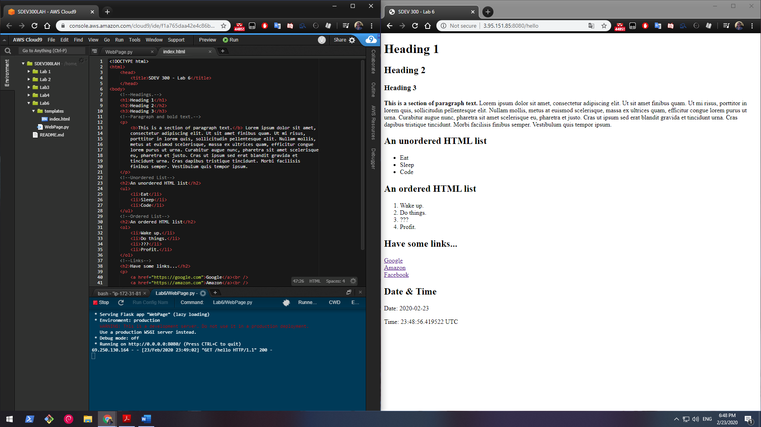

Screenshot of the index.html file inside project directory rendered by Flask backend.